INITIAL TRAINING

Cracow University of Technology
The Tadeusz Kościuszko

H&S TRAINING SYSTEM ^{[1]}

The employer is obliged to ensure training for employees in the scope of safety and hygiene of work prior to allowing them to work (initial Health and Safety training) as well as to carry out periodic trainings in this regard (periodic health and safety trainings).

H&S Trainings are obligatory and must be undertaken by each employed person.
These trainings occur during work hours and at the cost of the employer.

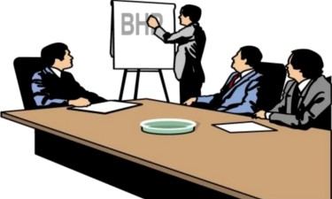

H&S TRAINING SYSTEM
Initial Health and Safety Trainings:

- H&S general training - familiarizing with the basic provisions of safety and hygiene of work contained in the Labour Code, in collective agreements or in the Bylaws of Work as well as with the regulations and principles of health and safety in place in a given workplace and the principles of providing first aid in case of accidents.

- H&S on-site training - familiarizing with environmental factors at work occurring in a given work position and with the professional risk related to the carried-out work, methods of protection against threats that may be caused by these factors as well as methods of safe conduct of work in the given work position

3

H&S TRAINING SYSTEM
General training

- occur prior to commencing the performance of work:
- newly employed persons,
- students holding internships with the employer,
- pupils from vocational schools employed for the purpose of gaining practical
knowledge about the profession.

- is carried out by:
- employee from the health and safety at work team,
- person conducting tasks of this team for the employer,
- employer who conducts such tasks by himself,
- or employee designated by the employer, possessing the knowledge and the skills necessary to provide proper realization of the training programme, holding a valid certificate of completion of the training in the field of safety and hygiene of work.

H&S TRAINING SYSTEM
Job position training:
- Are held by:
- employees employed on the blue-collar position,
- and other position on which a threat to harmful to health, burdensome or hazardous factors occurs;
- employee transferred to a position specified above,
- pupil undertaking practical profession training and student undergoing.

- is carried out by:
- designated by the employer persons who supervises employees
- or employer

if these persons possess adequate qualifications and professional experience are trained in the scope of methods of conducting the on-site training.

H&S TRAINING SYSTEM

The employee cannot be allowed to work without undergoing the H&S training.

Labour Code:
Art. 237³ § 1. It is not allowed to let an employee commence work with respect of which they do not possess proper qualifications or necessary skills as well as sufficient knowledge of the provisions and principles of safety and hygiene of work.

§ 2 (...) The employee training prior to commencing work is not required in case of undertaking work on the same work position which he or she occupied for a given employer directly prior to establishing subsequent employment contract for that employer.

MEDICAL TESTS

Initial medical tests must be carried out with respect to:

- persons newly employed by the company,
- Young employees transferred to other work positions and other employees transferred to a work position on which harmful factors for health or burdensome conditions occur.

MEDICAL TESTS

Medical tests are not obligatory in case of persons:

- re-employed to work by the same employer for the same work position or for the work position according to the same working conditions within 30 days after termination or expiry of the previous employment relationship with this employer;

- Employed to work for another employer for a work position within 30 days after termination or expiry of the previous labour relationship should they present a valid medical certificate noting lack of contraindications to work in the conditions of work specified in the medical test referral while the employer notes that these conditions correspond to the conditions occurring in a given work position with the exclusion of persons employed to carry out particularly hazardous works.

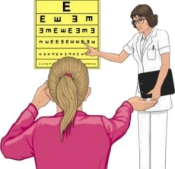
MEDICAL TESTS

Periodic and control medical tests:

An employee is subjected to periodic medical tests.

In case of inability to work which lasts longer than 30 days and is caused by illness the employee is subjected to control medical tests in order to establish capacity to perform work on the so-far position.

Periodic and control medical tests are conducted, in possible, during work hours. The employee maintains the right to remuneration for the time of absence at work due to conducted tests.

The employer cannot admit to work an employee who does not possess a valid medical decision noting lack of counterindications to work on the specific work position.

OBLIGATION OF THE EMPLOYER

The employer bears responsibility for the state of safety and hygiene of work in the workplace.

The employer is obliged to protect health and life of employees through ensuring safe and hygienic conditions of work with appropriate use of achievements of science and technology. In particular, the employer is obliged to:

- maintain construction objects and premises located therein as well as the terrains and devices related to them in a state which ensures safe and hygienic working conditions,
- ensure that work premises are proper for the type of conducted works and for the number of employed personnel,
- organize work in a manner that ensures safe and hygienic conditions of work,
- ensure adherence to the provisions and principles of safety and hygiene of work in the workplace, issue orders of removal of any deficiencies in this scope and order conduct of these orders,

OBLIGATION OF THE EMPLOYER

- ensure conduct of injunctions, presentations, decisions and ordinances issued by supervisory bodies controlling the workplace,
- apply preventive measures with respect of professional diseases and other diseases related to the conducted work,
- ensure proper hygienic-sanitary devices to employees and provide the necessary personal hygiene means as well as ensure means for provision of first aid in sudden cases, fighting fires and evacuation of personnel,
- ensure training for the employees in the scope of safety and hygiene of work,
- cover the costs of medical tests,
- establish the types of personal protection means and work clothing as well as footwear the application of which on specific work positions is obligatory,

OBLIGATION OF THE EMPLOYER

- provide the employees with free personal protection means securing them against the impact of hazardous and harmful for health factors occurring in the work environment and notify them of the methods of applying these means,
- if the employer cannot ensure work clothing, these actions may be conducted by the employees themselves provided that the employer pays them the financial equivalent in exchange,
- assess and document the professional risk related to the conducted work and apply the necessary preventive measures which decrease the risk, notify the employees of the professional risk that is related to the conducted work and about the principles of protection against threats.

The employer and the person managing the employees are obliged to be familiar, in the scope necessary to perform obligations they are entrusted with, the provisions of labour protection, including the provisions and principles of safety and hygiene of work.

OBLIGATIONS OF PERSONS SUPERVISING THE WORK OF EMPLOYEES
^{[4]}
In accordance with Art. 212 of the Labour Code the person managing the employees is obliged to:

- organize work positions in accordance with the regulations and principles of safety
and hygiene of work;
- look after the efficiency of personal protection means and their application in accordance with their designation;
- organize, prepare and conduct works taking into consideration securing the employees against accidents at work, professional diseases and other diseases related to the conditions of work environment;
- look after safe and hygienic state of premises where work is carried out and the technical equipment which is used as well as the fitness of group protection means and their application in accordance with their designation;
- enforce adhering by the employees to the provisions and principles of safety and hygiene of work;
- ensure conduct of orders of the doctor who performs healthcare over the personnel.
OBLIGATIONS OF PERSONS SUPERVISING THE WORK OF EMPLOYEES
§2 Appendix no. 1 to the Bylaws of Work
- Heads of organizational units are obliged to organize work stations in accordance with the following provisions and principles of health and safety at work:

- 1) defining actions, duties and responsibilities on the work position,
- 2) equipping the work positions appropriately in safe tools, devices and machines that fulfil the requirements concerning declaration of conformity specified in separate regulations,
- 3) devices and other technical equipment which are temporarily unfit, damaged or remaining in repair must be clearly marked and secured in a manner that prevents their switching on,
- 4) providing the employees with free work clothing and footwear as well as personal protection equipment, securing them against the impact of hazardous and harmful for health factors that occur in the work environment*
- 5) providing job instructions,
- 6) granting employees workplace job instructions and informing them of the professional risk related with the conducted work,
- 7) ensuring ongoing supervision in the scope of abiding by the provisions and principles of safety and hygiene of work,
- 8) timely conduct of medical tests in the scope of preventive protection of employee heath in the respective units,
- 9) obligatory ordering tests and measurements of factors harmful for health which occur at PK and the results of such tests and measurements to be disclosed to employees through placing them on the work positions and through submitting the results to the Department of Safety and Hygiene of Work,

*Principles of providing personal protection means to PK employees and principles of delivery of personal protection means such as work clothing and footwear. (Appendix no. 17 to the Bylaws of Work).

OBLIGATIONS OF PERSONS SUPERVISING THE WORK OF EMPLOYEES

§3 Appendix no. 1 to the Bylaws of Work

- Heads of organizational units in which pilot chemical, biological, physical or other tests are carried out which may pose a threat to life and health of persons participating in these processes are obliged to elaborate instructions of conducting such experiments. Instructions ought to contain the provisions concerning preventing threats to human health and life.

OBLIGATIONS OF PERSONS SUPERVISING THE WORK OF EMPLOYEES
§ 4 Appendix to the Bylaws of Work
Person managing employees is obliged to:

- organize work positions in accordance with the regulations and principles of safety and hygiene at work,
- look after the efficiency of personal protection means and their application in accordance with of,
- organize, prepare and conduct works taking into consideration securing the employees against accidents at work, professional diseases and other diseases related to the conditions of work environment,
- look after safe and hygienic state of premises where work is carried out and the technical equipment which is used as well as the fitness of group protection means and their application in accordance with their designation,
- enforce adherence to the provisions and principles of safety and hygiene at work by employees,
- ensure conduct of orders of the doctor who performs healthcare over the employees

OBLIGATIONS OF PERSONS SUPERVISING THE WORK OF EMPLOYEES

Heads of organizational units in which didactic classes are carried out in labs, workshops and specialist work rooms are obliged to organize the didactic process in such a way so as to ensure:

- Necessary personal protection means for students and doctoral students depending on the type of classes and the specificity of individual departments,
- training in the scope of H&S for all students commencing education at PK and for participants of doctoral studies,
- placement in a visible and easily-accessible place in the laboratories and specialist workrooms of order rules defining the detailed provisions and principles of conducting classes as well as the H&S principles,
- conduct of classes with students by employees whose preparation guarantees conduct of classes in line with the provisions and principles of safety and hygiene of work,
- conduct of medical tests among students and doctoral students exposed to operations of harmful or hazardous factors for health at PK in the mode specified in separate regulations.

OBLIGATIONS OF PERSONS CONDUCTING CLASSES
Class tutor is responsible for the safety of students during the conducted classes.

Persons conducting classes with students in labs, workshops and specialist workrooms and persons running PE classes are obliged to:
- Be familiar with the provisions and principles of H&S and principles of providing first aid in the scope necessary to carry out classes in accordance with these provisions and principles,
- check the technical state of devices and machines sand of electrical installations as well as the overall state of the lab or of the specialist workroom and whether it does not pose a threat to student life and health prior to commencing classes and allowing students to attend them,
- familiarize students with H&S provisions and the binding Bylaws in laboratories, workrooms and workshops in which harmful or hazardous factors occur.
OBLIGATIONS OF PERSONS CONDUCTING CLASSES

In case of noting that the place in which classes are to be conducted or the state of devices located therein may pose a threat to students’ safety, the class tutor is obliged to cease commencement of classes, stop the classes or specify the tasks and manner of proceeding in order to ensure safe conduct of such classes.

Appendix no. 1 to the Bylaws of Work “Obligations and responsibility of organizational unit heads and of the supervising persons concerning ensuring safe and hygienic conditions of work and education at PK”.

EMPLOYEE OBLIGATIONS

LC Art. 211 Abiding by the provisions and principles of health, safety and hygiene of work is a basic employee obligation. In particular, an employee is obliged to:

- be familiar with the provisions and principles of safety and hygiene of work, participate in the training and on-site training in this scope and subject themselves to the obligatory verification exams in this regard,
- conduct of work in a manner compliant with the provisions and principles of Health and Safety and adhere to the orders and instructions of superiors ordered in this regard,
- look after proper state of machines, devices and tools as well as the equipment and of the order and tidiness in the workplace,
- apply collective protection means as well as the assigned personal protection means and work clothing and footwear in line with their designation,

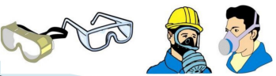
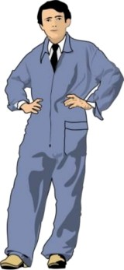
EMPLOYEE OBLIGATIONS

- undergo initial, periodic and control as well as other recommended medical tests and adhere to the doctor’s instructions,
- notify the superior immediately of an accident noticed in the workplace or of a threat of human life or health and warn co-workers as well as other persons remaining in the area of the threat of the exposure to danger,
- co-act with the employer and the superiors in fulfilling obligations concerning safety and hygiene of work.

EMPLOYEE RIGHTS

In case when conditions of work are not compliant with safety and hygiene of work provisions and create a direct exposure to employee life or health or when the conducted work poses a threat to other persons, the employee is authorized to refrain from carrying out the work through immediately notifying their superior of this fact.

Should refraining from continuing work not remove the threat, the employee is entitled to abandon the place of exposure, whilst immediately notifying their superior of this fact.

The employee maintains the entitlement to remuneration for the time of discontinuing work or abandoning of the exposure area.

The employee maintains the right, post prior notifying their superior, to refrain from performing work which requires special psycho-physical fitness in case when their psycho-physical state does not ensure a safe conduct of work and poses a threat to others.

RESPONSIBILITY OF EMPLOYEES

Art. 108 of the Labour Code
§ 1. Failure to abide by the established organization and order in the work process and to adhere to the provisions of safety and hygiene of work, fire protection provisions and the adopted manner of confirming arrival and presence at work as well as justification of absence at work by the employee may result in the employer applying:
- punishment of a warning;
- or a punishment of reprimand.

§ 2. Failure to abide by the provisions of safety and hygiene of work or the fire provisions by the employee or leaving work without justification, arriving to work under the influence of alcohol or consuming alcohol in the workplace may result in the employer applying a financial penalty.
Each employee who conducts their work in a hazardous manner, non-compliant with the provisions, posing through this a threat to others or to themselves may be punished.

RESPONSIBILITY OF EMPLOYEES

Financial penalty for a single overrun or for each day of unjustified absence cannot exceed 1-day's remuneration for that employee and in total, financial penalties cannot exceed one-tenth of remuneration granted to the given employee after deductions specified in Art. 87 § 1 points 1-3 of the Labour Code, that is:

From remuneration for work — after deducting social insurance contributions and advances towards personal income tax, the following shall be subject to deduction:
  - receivables for satisfying alimony provisions,
  - receivables for coverage of other provisions than alimony provisions,
  - money advances granted to the employee
  - financial penalties provided for in Art. 108.
Penalty payments shall be designated for improvement of safety conditions.

PROTECTION OF WORK OF PREGNANT WOMEN AND BREASTFEEDING WOMEN [5]

Pregnant women and breastfeeding women remain under special protection:

- it is forbidden to terminate or dissolve employment contract of a female employee in the period of her pregnancy and in the period of her maternity leave (unless the plant is liquidated or has announced bankruptcy and trade unions expressed consent for the proposed term of employment contract termination);
- pregnant women cannot be employed during night shifts nor during overtime hours. They cannot also be delegated to work without their consent outside of their permanent work location;
- a woman employed to perform work forbidden in case of pregnant women or in case of submission of doctor’s certificate that due to health status she should not conduct the so-far work – must be transferred to another work station (if such transfer involves decreasing remuneration, the employee is entitled to a compensatory allowance).
- the employer must also release the pregnant employee from work in order for her to conduct medical tests in relation to the pregnancy should these tests not be possible to be conducted outside of working hours. Absence at work on account of such tests is subject to remuneration entitlement.
- an employee breastfeeding more than 1 baby is entitled to two 45-minute breaks at work each. Breaks may be granted jointly upon request of the employee.
- women looking after a child below the age of 4 cannot be employed for overtime work or during night shifts without their consent. They cannot also be delegated to work outside of their permanent work location.

PROTECTION OF WORK OF PREGNANT WOMEN AND BREASTFEEDING WOMEN
LIST OF ONEROUS, HAZARDOUS OR HARMFUL WORKS FOR HEALTH OF PREGNANT AND BREASTFEEDING WOMEN:

Works related to excessive physical effort, including manual transport of loads:
including:
a) manual lifting and moving items with weight exceeding 1 kg;
b) manual lifting upwards of:
- items during constant work,
- Items with a mass exceeding 1 kg during ad hoc work, defined in point 1 of the Regulation;
d) works in a constrained posture;
e) works in a standing position for the total of more than 3 hours during a single shift, whilst the time spent in a standing position cannot each time exceed 15 minutes, after which time a 15-minute break should occur;

PROTECTION OF WORK OF PREGNANT WOMEN AND BREASTFEEDING WOMEN
f) works on position with screen monitors — in the total time exceeding 8 hours per day, whilst the time spent servicing the screen monitor cannot each time exceed 50 minutes after which a 10-minute break should occur, which is calculated into the working time;
g) works in a cold, hot or alternate microclimate (point II of the Regulation of the Council of Ministers from 3 April 2017)
h) works exposed to noise or vibrations;
i) works exposed to operations of electromagnetic field with frequency from 0 Hz to 300 Hz and to ionizing radiation;
j) works in an increased or lowered pressure;
k) works with exposure to operations of harmful chemical substances;
l) works exposed to severe physical or mental injuries.

PROTECTION OF WORK OF PREGNANT WOMEN AND BREASTFEEDING WOMEN

- Detailed list of cumbersome, hazardous or harmful works for the health of pregnant and breastfeeding women may be found in Appendix no. 20 to the PK Bylaws of Work.

PREMISES

Work premises are the premises designated for employee's work, in which the work is carried out.

Premises designate for employees may be divided into:

- premises for constant work - premises in which the total duration of stay of the same employee during a single working day exceeds 4 hours;
- premises for temporary work - premises for work, in which the total duration of stay of the same employee during a single working day lasts between 2 and 4 hours.

PREMISES

Work premises do not constitute premises in which:

- The total duration of stay of the same employees during a single shift is shorter than 2 hours and the conducted activities are of ad hoc nature, or the work involves supervision or maintenance of devices or cleanliness maintenance,
- technological processes occur which do not allow to ensure proper work conditions for employees in order to service them without applying personal protection means,
- breeding of plants or animals is conducted regardless of the time of stay of employees involved in their servicing in them.

PREMISES

The employer is obliged to maintain work premises in cleanliness and order and to ensure their periodic renovations and maintenance works.

Work premises and their equipment should ensure safe and hygienic working conditions to employees, in particular:
-> natural and artificial light,
-> proper temperature,
-> exchange of air,
-> protection against humidity, unbeneficial, thermal conditions and sun,
-> other harmful and burdensome factors for health.

PREMISES

Per each single employee employed in the premises designated for constant work there should be at least 13 sqm of free volume of the room and at least 2 sqm of free are of the floor.

The height of work premises in which harmful or cumbersome factors for health occur ought to exceed:
3 meters - if more than 4 persons remain there,
2.5 meters - if no more than 4 persons work in the premises and at least 2.2 meters of free premises volume fall per each one of them, in the service or small-scale production premises located in a residential building, if at least 15 meters of free volume of space fall per each employee,
2.2 meters - in watch rooms, lodges, storerooms, street kiosks, railway kiosks etc. as well as in premises located inside an open mezzanine in a larger room.

The height of work premises in which cumbersome or harmful for health factors occur.
Should exceed 3.3 meters.

PREMISES
The surface of windows to the surface of the floor in the premises
ought to exceed 1:8.

Lights requirements in work premises are specified by the PN-EN 124641:2012

- Electrical lighting should be adjusted to the conditions occurring in a given working station and it should ensure comfort of visual work.

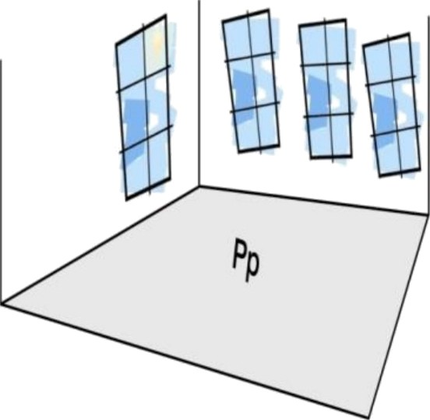
- Sample values of lighting system intensity:
- warehouse 100 lx
- 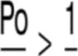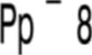cloakroom, dining room 200 lx
- office 500 lx

PREMISES

Temperature of work premises

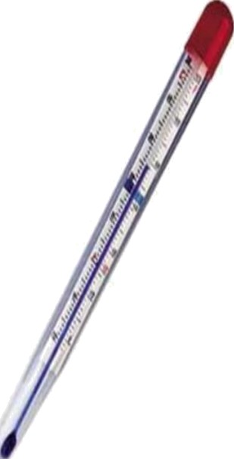
Proper temperature levels must be maintained in work premises, adjusted to the type of conduct work, not falling below:

- 14 degrees of Celsius in case of physical work
- 18 degrees of Celsius in case of office work

Managers of all organizational units are obliged to ensure during the days in which the temperature exceeds 28 degrees of Celsius cooling beverages for the employees on their working stations and employees performing work in an open space when temperature exceeds 25 degrees of Celsius *. [8]]

*Official order of the Rector of the Tadeusz Kościuszko Cracow University of Technology from 3 July 2009 concerning provision of cooling beverages to employees

COMPUTER WORKSTATIONS

Organization of a workstation equipped in a computer

Proper selection of equipment for the workstation, its ergonomic arrangement and proper conditions in the work premises are an essential part of work.

COMPUTER WORKSTATIONS
Work premises with computers
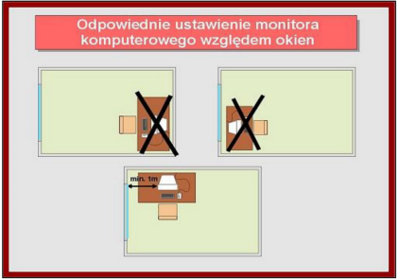 | In order to avoid tiring light reflections in the monitor and its vicinity one must:  • set up monitors perpendicularly to the window,  • apply scattered light to illuminate the premises,  • avoid polished furniture.
It is crucial for such elements as documents, keyboard, screen were located in the best field of vision.
Proper setting up of the computer monitor with respect to windows

COMPUTER WORKSTATIONS

- Office desks:
- Enabling comfortable set up of workstation accessories, including diverse height of setting up the screen monitor and keyboard,
- width and depth of the table ought to ensure sufficient surface for easy use of work position accessories,
- set up of the keyboard at the right distance not below 10 cm between the keyboard and the frontal part of the table,
- tabletop surface must be matt;

COMPUTER WORKSTATIONS
- Chairs:
- stable, on wheels with a minimum five-leg basis,
- equipped in height regulation of the seat in the range of circa 40 - 50 cm, counting from the floor,
- equipped in height regulation and inclination of the largest in the range of: 5° forwards and 30° backwards,
- possibility of turning around the chair axis by 360°,
- profiled seat panels and backrest panel corresponding to the natural bend of the spine and the thigh section of lower limbs
- armrests,
- mechanisms of regulating the height of seat and the inclination of the backrest should be easily available and simple in use;

The height of desk and of the chair seat ensure natural position of upper limps while using the keyboard, subject to maintaining at least a right angle between the arm and the forearm.

COMPUTER WORKSTATIONS

3. Screen monitors:
- symbols on the screen should be clear and readable,
- stable image,
- brightness and stability of signs on the screen should be easy to regulate,
- regulations of monitor settings should enable inclination of the screen at least 20° backward and at least 5° forward and turning around by at least 120° (60° in each direction).

COMPUTER WORKSTATIONS
Distance between employee eyes and the screen should equal circa 40-75 cm.

During constant work by the computer the employee is allowed to have a 5-minute break per each worked hour.

The employer is obliged to ensure corrective glasses for employees if the results of their vision tests conducted as part of the preventive healthcare indicate the need to wear glasses during work by the computer.

PROFESSIONAL RISK [6]

Professional risk - likelihood of occurrence of undesired events related to the conducted work, causing loss, in particular, occurrence in employees of adverse health effects as a result of professional threats occurring in the work environment or the manner of work conduct.
The goal of professional risk assessment is to identify all significant threats occurring in the workplace and to estimate the risk involved.
The conduct of professional risk assessment and its document is an obligation of all employers, regardless of the industry, volume of employed persons, whilst familiarizing with its content is an obligation of each employee.
Risk assessment should be performed both while creating new work positions and while introducing new technological processes, applying new technical devices, materials and substances, changing work organization and work positions and changing the applied protection measures.

PROFESSIONAL RISK
Occupational disease - is a disease caused by the impact of harmful factors to health occurring in the work environment or related to the manner of work conduct which has been listed in the list of occupational diseases.

The relevant state sanitary inspector who obtained the submission of suspicion of occupational disease initiates the proceeding and, in particular, directs the employee who is suspected of the above to medical tests in order to detect professional diseases to the decision-making unit as well as notify the employer and the medical unit supervising the health of the employee.
Factors harmful for health, cumbersome and hazardous occurring in work processes:
- Hazardous - factor the impact of which on the working person leads or may lead to an injury,
- Hazardous factors that may occur in the work environment causing mainly injuries include mechanical factors such as slippery:
- uneven surfaces
- falling objects
- sharp tools and corners and sharp edges of equipment that limit
- free space (entrances, passengers, access points)
- movable, mainly rotating parts of devices and transport means.
- Electric current must also be considered a hazardous factor

WORKING STATION
- Hazardous - factor the impact of which on the working person leads or may lead to an injury,
- Harmful factors in the work environment:
- Chemical factors - factors which, due to their physio-chemical properties or their impact on people and the manner in which they are applied or present in the workplace may pose a threat to safety and health of employees. These include chemical factors and dusters for which values of the highest allowed concentrations are established.
- Harmful physical factors - they cover noise and ultrasound noise, vibrations impacting a human organism through upper limbs and vibrations acting overally on human organism, microclimate, optical radiation, electromagnetic field.
- Biological factors - cover micro and macro organisms that may cause occupational diseases (infectious or allergic diseases). These include, among others, bacteria, viruses, parasites, fungi.
- Cumbersome factor - factor which impacts a working person and may cause malaise or excessive fatigue whilst not causing any durable worsening of health state. These include, among others: microclimate, monotony mental burdens, static burden, lights, physical effort.

SAFETY DATA SHEET

Safety data sheet is a document which is a generally accepted manner of providing information about hazardous chemical substances and/or mixtures of such substances to their recipients in the area of the European Union. It is this document that is targeted at facilitating the employers to state that there are hazardous chemical measures in the work place as well as to form a risk assessment for the health and safety of employees stemming from their application. This document informs in detail of hazardous properties of individual chemical agents, type and dimensions of the threat it creates and the principles of proceeding with them.

Employer (Journal of Laws from 2003, No. 169, item 1650 as Amended) is obliged to notify the employees of physical, chemical and biological properties of materials applied in the workplace as well as of semi-finished products and finished goods and the risk for health and safety of employees related to their application and to the manners of their safe application and ways of proceeding in emergency situations.

ACCIDENTS
Accidents at work
an accident at work signifies a sudden event caused by an external cause leading to an injury or death which occurred in relation to work.

Accident equal to accident at work
an accident which occurred to the employee is treated equally to accident at work, in the scope of entitlements to benefits specified in the Act on Accidents when the employee had such an accident:
- during business travel, unless the accident was caused by the employee’s actions which are unrelated to the conduct of entrusted tasks;
- during training in the scope of general self-defence;
- while performing tasks ordered by trade union organizations operating in the workplace.

Accident on the way to or from work.
if the event is sudden and it is caused by an external cause that occurred on the way to or from work. If this route is the shortest one and was not discontinued,
- the way to work was discontinued but the break was vitally justified and its duration did not exceed the need limits,
- the route was not the shortest but due to communicational reasons it was the most convenient for the employees.

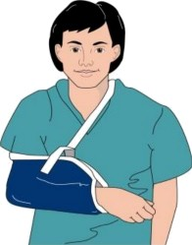
ACCIDENTS

Severe accident - an accident as a result of which severe damage of body occurred, namely: loss of sight, hearing, speech, ability to reproduce or other damages to the body or health disorder infringing the basic organism functions as well as an incurable diseases or life-threatening disease, permanent mental illness, durable, complete or significant inability to work in one's profession or permanent, serious body desecration or deformation.

Fatal accident - an accident as a result of which death occurred on the place of accident or in the period not exceeding 6 months from the date of the accident.

Group accident - an accident as a result of which at least two persons were affected.

ACCIDENTS

Each employee who suffered an accident at work or is a witness of one is obliged to immediately report it to their superior and to the Health and Safety Department (tel. 2223, 2950).
A fatal, severe or group accident must be immediately reported to the Rector.
Post-accident procedure commences with an appointment of the relevant post-accident team. It is composed of the Health and Safety Specialist and the Social Labour Inspector (SIP).

The post-accident team must realize the post-accident procedure within 14 calendar days. During that time accident place must be inspected, the affected person must give explanations should their health status allow for this. Information concerning the accident must be gathered from witnesses and subsequently, causes and circumstances of accident occurrence must be established. Based on the gathered information post-accident documentation is elaborated and preventive means are specified in order to limit occurrence of similar events in the future.

ACCIDENTS
The following benefits may be granted on account of the accident at work or an occupational diseases:
1) “sickness benefit”— for an insured person whose inability to work was caused by an accident at work or an occupational disease;
2) “rehabilitation benefit” — for an insured person who, after exhaustion of the sickness benefit” continues to remain unfit for work and their further treatment or rehabilitation provide a chance to regain ability to work;
3) “compensating benefit” — for an insured person who is an employee whose remuneration was decreased as a result of permanent or long-term damage to health;
4) “one-off compensation” — for an insured person who suffered a permanent or long-term damage to health;
5) “one-off compensation” — for members of the family of a deceased insured person or pensioner;
6) “pension on account of unfitness for work” — for an insured person who became unfit for work as a result of an accident at work or due to occupational disease;

ACCIDENTS

7) “training pension” — for an insured person with respect of whom purposefulness of professional pre-qualification was granted on account of unfitness to work in the so far profession, caused by accident at work or an occupational disease;
8) “family pension” — for members of the family of a deceased insured person or pensioner authorized to receive pension on account of accident at work or occupational disease;
9) “family pension allowance” — for a full orphan;
10) carer's allowance;
11) reimbursement of treatment costs in the scope of dentistry and protective vaccinations and provision of orthopaedic devices in the scope specified in the Act*.

* Act of 30 October 2002 on social insurance on account of accidents at work and occupational diseases.

ACCIDENTS

Sickness benefit and rehabilitation benefit from the accident insurance are granted at the level of 100% of the assessment basis

One-off compensation at the level of 20% of average remuneration for each percent of permanent or long-term damage to health may be granted.

Granting or denying a one-off compensation and establishing its level occurs by way of a decision issued by the Social Insurance Institution (ZUS).

Payment of compensation occurs within the term of 30 days from the date of issuance of ZUS's decision.

ACCIDENTS

IMPORTANT !
Benefits on account of accident insurance are not granted in situations where the sole cause of accident at work was a proven breach by the insured person of provisions concerning health and safety protection, caused by them intentionally or as a result of a flagrant negligence.
Benefits under accident insurance cannot be granted to an insured person who contributed in a significant degree to causing the accident while being under the influence of alcohol or narcotic drugs.

ACCIDENTS

On account of accident on the way to or from work, similar as in the case of accident at work the employee is entitled to 100% paid sick leave.

However, as opposed to accidents at work an on-off compensation specified and paid by ZUS shall not be granted.

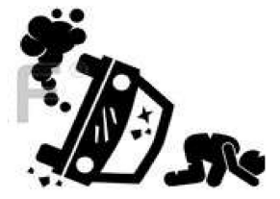
NEAR MISSEVENT
Accident pyramid allows to understand the fact that in order to eliminate accidents one must focus on grassroots work. By eliminating hazardous events and conditions we will eliminate near miss events and accidents from the higher levels of the pyramid. The statistics show that approx. 95% of accidents are the result of behaviours and these may be avoided.

Śmierć - death
Wypadek ciężki - Severe accident
Wypadek związany z utratą czasu pracy – Accident related to loss of work time
Udzielenie pierwszej pomocy - Provision of first aid
Zdarzenia potencjalnie wypadkowe - Potentially accident-involving event
Niebezpieczne zachowania i warunki pracy – Hazardous behaviours and working conditions

NEAR MISS EVENTS

Usually a near miss event is understood as an undesired event that took place in relation to the conducted work, did not cause an employee injury or/and damage to work tools but as its result a likelihood occurred of occurrence of such effects.
An example of near miss events may be:
- tripping over obstacles located in or along entrances or passages to working positions, i.e. left boxes, cables
- damaging packaging of advertising materials, i.e. soaking due to improper transport or storage,
- damaging of an electric socket or power cable, damaging of electrical device i.e. pouring liquid during consumption of meals,
- falling tools on the construction site or goods falling down from racks.

FIRST PRE-MEDICAL AID

IF EVERY 10TH PERSON DIED WHILE RECEIVING FIRST AID ONE MILLION PERSONS WOULD BE SAVED EVERY YEAR

PRE-MEDICAL FIRS AID
In accordance with the template elaborated by the Red Cross, the course of providing aid in sudden accidents or situations may be presented in the form of a chain:

Early assessment of the situation, | Early resuscitation | Early defibrillation | Early specialist
call for help | cardiac-respiratory CPR |  | Medical help

FIRST PRE-MEDICAL AID

1. The victim is unconscious, breathing – safe position
2. The victim is unconscious, not breathing - BLS + AED
3. Foreign body in respiratory tracts - choking
4. Problems with breathing, asthma
5. Pain in one's chest
6. Epilepsy
7. Fainting
8. Stopping the bleeding
9. Foreign body in a wound
10. Foreign body in an eye
11. Burns
12. Nosebleed
13. Injured hand – sling
14. Evacuation - Rautek's manoeuvre
FIRST PRE-MEDICAL AID

CONTENT OFFIRST AID KIT | No. | Element of equipment | Stationary first aid kit | Portable first aid kit DIN 13157 PLUS
 | 1 | Plaster adhesive DIN 13019 - A (5m x 2,5 cm) | 1 | 2
 | 2 | Plaster DIN 13019 - E (10 x 6 cm) | 4 | 16
 | 3 | Dressing for fingertips | 4 | 8
 | 4 | Finger dressing (12 x 2 cm) | 4 | 8
 | 5 | Plaster with a dressing (1,9 x 7,2 cm) | 4 | 8
 | 6 | Plaster with a dressing (2,5 x 7,2 cm) | 4 | 16
 | 7 | Individual dressing DIN 13151 - K (6 x 8 cm) | 1 | 2
 | 8 | Individual dressing DIN 13151 - M (8 x 10 cm) | 2 | 6
 | 9 | Individual dressing DIN 13151 - G (10 x 12 cm) | 1 | 2
 | 10 | Dressing veil DIN 13152 - A (60 x 80 cm) | 1 | 2
 | 11 | Compress (10 x 10 cm) | 3 | 12
 | 12 | Eye compress (min. 5 x 7 cm) | 2 | 4
 | 13 | Cold compress (min. 20 cm2) | 1 | 2
 | 14 | Scrubber for eye rinsing (workshops, labs) | 1 | -
 | 15 | Rescue blanket 160 x 210 cm | 1 | 2
 | 16 | Elastic band DIN 61634 - FB 6 (4m x 6cm) | - | 4
 | 17 | Elastic band DIN 61634 - FB 8 (4m x 8cm) | 1 | 4
 | 18 | Triangular veil DIN 13168 - D | 1 | 4
 | 19 | Scissors DIN58279 - B (19 cm) | 1 | 1
 | 20 | Foil bag (min. 30 x 40 cm) | 1 | 4
 | 21 | Fiseline veil (min. 20 x 30 dm) | - | 10
 | 22 | Single-use gloves EN 455 (pc.) | 4 | 8
 | 23 | First aid instructions | 1 | 1
 | 24 | Table of content | 1 | 1

PRE-MEDICAL FIRST AID

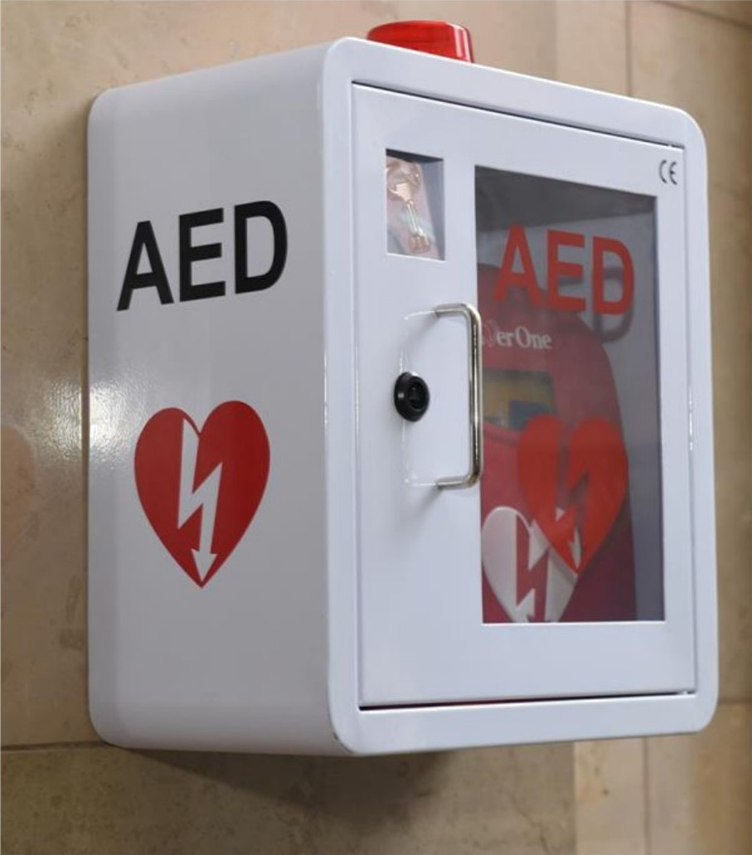
Automatic External
Defibrillator (AED)

Is a specialized computerized device which, through voice orders, guides a person providing first aid through the procedure of safe defibrillation of the person with ceased circulation.

Procedure of granting first aid

PRE-MEDICAL FIRST AID
Defibrillators at PK
- in the building of the Faculty of Civil Engineering by the main entrance from ul. Warszawska 24 (next to the lodges) ^{map 1}
- in the building of the Faculty of Engineering and Chemical Technology by the main entrance from the side of ul. Szlak (by the lodges)
- in the building of the Faculty of Architecture and the Faculty of Physics, Mathematics and Computer Sciences at ul. Podchorążych 1 (next to the lodges) ^{map 2}
- in the building of the Faculty of Architecture at ul. Kanoniczna 1 (in the lodges) ^{map 3}
- In the student residential area of PK In Czyżyny in the Student House no. 2 “Leon” (at the lodges) and in the Student Club “Kwadrat” (by the lodges) ^{map 4}
- in the area of the campus Czyżyny PK in: the building of the Centre for Organizing Trainings and Quality Systems (entrance to the building opposite the lodges), in building A (lodges) and D (by the entrance) of the Faculty of Mechanics at ul. Jana Pawła II 37 ^{map 5}
- in the Centre for Sport and Recreation of PK at ul. Kamienna (by the lodges) ^{map 6}
- in the Student House B-1 PK at uI. Bydgoska 19A (by the lodges) ^{map 7}
SELECTED INTERNAL REGULATIONS
- Ordinance no. 23 of the Rector of the Tadeusz Kościuszko Cracow University of Technology from 23 July 2007 ref. UR.O2O1-68/07 on training of employees in the scope of safety and hygiene at work ^{[1]}
- Ordinance no. 19 of the Rector of the Tadeusz Kościuszko Cracow University of Technology from 16 April 2015 ref. R.0201-23/15 on the principles of preventive organizational medical tests of the employees of the Cracow University of Technology ^{[2]}
- Ordinance no. 20 of the Rector of the Tadeusz Kościuszko Cracow University of Technology on assessment of professional risk in work positions at the Cracow University of Technology ^{[6]} as amended
- Ordinance no. 21 of the Rector of the Tadeusz Kościuszko Cracow University of Technology from 25 April 2018 ref. R0201.27.2018 on the principles of notifying about accidents related to work at the Cracow University of Technology and establishing their circumstances and causes ^{[7]}
- Ordinance no. 12 of the Rector of the Tadeusz Kościuszko Cracow University of Technology from 3 April 2013 ref. 0201-17/13 on the principles of applying hazardous substances and mixtures
- Official order. 7 of the Rector of the Tadeusz Kościuszko Cracow University of Technology from 3 July 2009 ref. R.0201-55/09 on providing cooling beverages to employees

WORK BYLAWS

WORK BYLAWS AT
The Tadeusz Kościuszko Cracow University of Technology [3]

Chapter I. General Provisions
Chapter II. Rights and obligations of the employer and employee
Chapter III. Working time
Chapter IV. Payment of remuneration for work
Chapter V. Discipline at work
Chapter VI. Safety and Hygiene of work and Fire Protection
Chapter VII. Protection of female and minor employees
Chapter VIII. Combating discrimination and mobbing
Chapter IX. Final and transitional provisions
Appendices

WORK BYLAWS

List of more significant appendices to the Work Bylaws:
- Appendix no. 1 to the Bylaws of Work “Obligations and responsibility of organizational unit heads and of the supervising persons concerning ensuring safe and hygienic conditions of education and work at PK”
- Appendix no. 16 “Principles of providing personal hygiene means for employees”.
- Appendix no. 17 “Principles of providing individual protection means and work clothing and footwear
- Appendix no. 18 “Equivalent for laundry and repair of work clothes”
- Appendix no. 20 “List of cumbersome hazardous or harmful works for the health of pregnant or breast-feeding women”
- Appendix no. 21 “List of works forbidden for adolescent workers and conditions of their employment in case of some of these works and list of work positions allowed to be conducted by adolescent workers for the purpose of obtaining professional training”
- Appendix no. 4 List of types of works that ought to be conducted by at least Two persons in case of which there is a possibility of occurring of special exposure to health or life”

SELECTED LEGAL ACTS
- Act of 26 June 1974 Labour Code (that is Journal of Laws from 2020, item 1320 )
- Regulation of the Minister of Labour and Social Policy from 6 September 1997 on general provisions of safety and hygiene of work (Journal of Laws from 2003, item 169 as amended)
- Regulation of the Minister of Science and Higher Education from 30 October 2018 on the manner of ensuring safe and hygienic conditions of work and education at the university (Journal of Laws from 2019 item 2090 )
- Act of 30 October 2002 on social insurance on account of accidents at work and occupational diseases (Journal of Laws from 2019 item 1205) .
- Regulation of the Minister of Labour and Social Policy from 24 December 2002 on detailed principles and mode of considering events as an accident on the way to or from work, manner of documenting it, sample accident card on the way to or from work and term of its elaboration (that is Journal of Laws from 2013 item 924)
- Regulation of the Council of Ministers from 3 April 2017 on the list of cumbersome, hazardous and harmful works for pregnant and breast-feeding women (Journal of Laws from 2017, item 796)

SELECTED LEGAL ACTS
- Regulation of the Minister of Economy and Labour from 27 July 2004 on trainings in the scope of safety and hygiene of work (Journal of Laws no. 180 item 1860 as amended)
- Regulation of the Minister of Economy from 30 October 2002 on minimum requirements concerning safety and hygiene of work in the scope of using devices by employees during work (Journal of Laws no. 191 item 1596 as amended)
- Regulation of the Minister of Labour and Social Policy from 1 December 1998 on safety and hygiene of work on positions equipped in screen monitors (Journal of Laws from 1998, no. 148 item 973)
- Regulation of the Minister of Labour and Social Policy from 12 June 2018 on the highest allowable concentrations and intensity of factors hazardous for health and work environment (Journal of Laws from 2018, item 1286).
- Regulation of the Minister of Infrastructure from 12 April 2002 on technical Conditions to be met by buildings and their location (that is, Journal of Laws from 2019, item 1065 as amended)
- Regulation of the Council of Ministers from 28 May 1996 on preventive meals and beverages (Journal of Laws from 1996, No. 60 item 279, as amended).

THANK YOU FOR YOUR ATTENTION

